# **Burnett County 4-H**

# **Youth Award Guidelines**

# **202**4**-202**5clover_color

# [**http://burnett.extension.wisc.edu/4-h-youth-development/**](http://burnett.extension.wisc.edu/4-h-youth-development/)

***On Facebook:*** [***www.facebook.com/BurnettCounty4H***](http://www.facebook.com/BurnettCounty4H)

***UPDATED November 2024***

# EXT_color-center

# 4-H tiff

# Dear 4-H member and family:

# During your time in 4-H, you will learn many different skills to help you grow as a person and to become a positive, successful and caring individual to yourself, family and community. The information in this packet is designed to help you learn some of these skills.

# Success in 4-H means getting the most out of your experiences by setting goals, making choices, keeping records of your progress and learning as you go. It also means learning how to lead, learn, work and have fun with others. Keep in mind that awards reflect only a part of 4-H success; true accomplishment comes with doing your personal best.

# The Guidelines set forth in this document will help you to understand what is required to compete for the many youth awards. The decisions of the Awards Committee are final. If you have any questions about award requirements or decisions of the Awards Committee, ask your club’s General Leader and/or the county UW-Extension 4-H agent.

# Please keep this packet for future reference.

# Thank you,

# Burnett County 4-H Leaders Association



For more information about the Burnett County 4-H organization:

UW-Extension Burnett County

4-H Extension Educator

7410 County Road K #107

Siren, WI 54872

Phone: 715/349-2151 or 608-347-6994 (Beth’s work cell)

Fax: 715/349-2102

# Forms and other information can be found on the web at:

# <http://burnett.extension.wisc.edu/4-h-youth-development/>

**4-H Terms**

# Achievement: Achieving in 4-H means a member completes all membership requirements of the 4-H club and county 4-H policies during the year (See General Achievement Guidelines).

# Awards Committee: A committee of the Leaders Association whose members review record books and decide upon award winners based on Record Book completion and 4-H Club leader recommendations. Their mission statement is to provide recognition to those members that exhibit extraordinary achievement through project work, leadership, community service and citizenship.

**Burnett County Leaders Association:** Organization which supports the county 4-H program by supporting volunteers, raising funds for 4-H, following 4-H policy, coordinating member recognition and providing opportunities for members.

**Club Leadership:** As a youth member, actively serving one’s club by such things as organizing meetings, activities, teaching projects, or serving as a club officer. Leadership can also involve leading other activities like saying the pledges before a club meeting, coordinating community service projects or helping younger members.

**Community service:** As a 4-H member and/or as a youth member of the community, giving your time and talent to projects, services or activities that benefit others or the community as a whole. Public youth contributions is a civic mission of 4-H.

**General Leader:** A volunteer or team of volunteers who provides overall 4-H club leadership and coordinates members, parents, and the involvement of other leaders.

**Junior Leaders Association:** Organization made up of 4-H youth grade 6 and older. Members work on leadership and citizenship skills through supporting the Leaders Association by planning county-wide 4-H events and educating younger 4-H members.

**Educational Experiences Scholarship Selection Process:** A cover letter, resume, and interview process that helps youth summarize their 4-H experience in an effort to show the Interview Team their growth and development throughout their 4-H career. Guidelines and samples can be downloaded from the Extension Burnett County 4-H Youth Development website. The Trip Award Selection Process is completed by 4-H members at least 14 years and older as of January 1 of the coming 4-H year.

**Project:** A topic that a member wants to explore during the year. 4-H members are required to enroll in one or more projects (depending upon grade level) each year using the annual Wisconsin 4-H Project Guide (available from a club General Leader or Burnett County 4-H Youth Development website). Projects range from large and small animals to arts and crafts, theatre arts to child development, bicycling to recycling, and much more.

**Youth Leadership Project:** A project enrolled in by youth to help develop leadership skills. Youth learn how to develop a leadership plan, teach, accept responsibilities and encourage others.All Junior Leaders group members are highly encouraged to make this one of their projects.

**Record Book:** A place to keep your goals and accomplishments throughout the 4-H year. Record books are shared with your General Leader at the end of the year and may advance to the Awards Committee for consideration for county-based awards. It can serve as a scrapbook of your 4-H experience. A treasure to look back on someday.

**General Achievement Guidelines**

# These are the minimum expectations for all 4-H members on an annual basis.

# Burnett County 4-H year is October 1-September 30th (The 4-H Fiscal year is July 1-June 30).

# Members need to complete the following six things in order to achieve. By achieving, members receive a yearly achievement pin and may qualify for additional awards based a member’s record book and on the recommendations of a member’s club General Leader.

# Criteria – Member must:

# Members enrolled in the second year and beyond enroll in a minimum number of projects by grade:

# Grades K-2, at least one project

# Grades 3-5, at least two projects

# Grades 6-8, at least three projects

* Grades 9 and over, at least four projects

# Be active in club membership (according to club guidelines).

# Document your project work to include evaluation of each project taken.

# Enter at least one item to be judged or exhibited publicly outside of the club level for each project in which you are enrolled (at a fair, contest, revue, organized competition, pow wow, etc. in which the member’s skills can be tested/judged by others).

# Maintain and turn in a record of the members year in 4-H (see record book guidelines below).

# Have a clean disciplinary record within the 4-H system from September 15 to September 15 of the judging year.

# **Record Book Guidelines**

The record book year is October 1-mid September (Record Books are due to your Club Leader before the September Leaders Association meeting).

# All Cloverbuds and standard record book forms can be downloaded from the UW-Extension Burnett County website at http://burnett.uwex.edu/4-h-youth-development/.

Green 4-H Record Book covers and binders can be obtained from your club’s General Leader or the Extension Burnett County Office.

Each club may recommend two members per grade division.

A leader recommendation sheet (provided to and filled out by a club’s General Leader) must be turned in with each record book recommended for county awards. If the sheet is not included, your book will not be considered for any awards.

# Cloverbuds (Kindergarten - 2nd grade):

# This age group must use the *Cloverbud Activity/Record Book* available from the Extension Burnett County Office.

All Cloverbud Activity/Record Books must:

1. Be neat.
2. Complete a minimum of 7 activities throughout the Cloverbud Activity/Record Book.
3. Complete Cloverbud Activity/Record Book in his/her own handwriting,except for extenuating circumstances that are communicated to the awards committee in advance, i.e. the member does not know how to write or has a disability that does not permit him/her to write.

# Grades 3 and up:

# This age group must maintain the standard 4-H record book (see Appendix A). Youth in this age group may download the pages and forms needed and complete the record book through the use of a computer, *or* complete the record book in his/her own hand writing, with exception to extenuating circumstances that are communicated to the awards committee in advance, i.e. the member has a disability that does not permit him/her to write.

Grades 3 and up

All record books must:

1. Be neat.
2. Have completed inside front and back covers, using the green 4-H Record Book cover.
3. Contain a *Photo Page*.
4. Contain statement of true and own work.
5. Contain a *4-H Activities* page.
6. Contain a *4-H Yearly Calendar* highlighting what you have done each month.
7. Contain a *Project Plan Evaluation* for each project in which you are enrolled.
8. Have parents’ or leader’s comments filled out on the project plan page(s).
9. Contain a *My 4-H Story* page to summarize your 4-H year.
10. Contain pictures, newspaper articles, and judge’s sheets from contests to enhance the record book.
11. Include two, but not more than three, consecutive years in the record book at judging time (if applicable)
12. Be collected in a Green 3 Ring Binder provided by the County/Club. You also may use page protectors if you would like or 3-hole punch the pages.

Grades 7 and up

All record books must:

1. Follow 1-12 above.
2. Contain information on leadership activities/opportunities.
3. Include two, but not more than three, consecutive years of leadership (if possible).

Order for the record book – Current year on top

1. Current photo and demographic data
2. Activities
3. Yearly Calendar
4. Project Evaluation(s)
5. 4-H Story
6. Photos, judges sheets, newspaper clippings, etc.

DO ☺ DO NOT ☹

☺ Make it about YOU, not your club.☹ Do not include ribbons or pins.

☺ Highlight your name in included articles. ☹ Do not type unless you are in Grades 3 or

☺ Work on your record book all year. above.

☹ Do not include whole Bugles, whole programs,

or 4-H project materials.

**Outstanding Record Book Awards**

# The Outstanding Record Book Award is awarded to members who exhibit exemplary record books, based on the record book guidelines. Record books are judged on the content of what you write about and include, not the thickness or weight of the book. Each club may recommend two members per division. The Awards Committee may give one award per grade division each year.

# Record books are judged in the following grade divisions (grade as of January 1 of the enrollment year):

# Grades 3-4

# Grades 5-6

# Grades 7-8

# Grades 9 and up

# Criteria – Member must:

Turn in completed record book which reflects the Record Book Guidelines (see pages 6 and 7).

**Outstanding Cloverbud Award**

All Cloverbuds will be recognized for their contributions to the 4-H program. Cloverbuds who successfully complete and submit their Cloverbud Activity/Record Book to their Club General Leader prior to the deadline may be recognized with an Outstanding Cloverbud Award. General Leaders shall submit all Cloverbud Activity/Record Books received so awards for these members can be given.

Criteria – Member must:

1. Meet general achievement guidelines.
2. Complete Cloverbud Record Book per guidelines.
3. Demonstrate enthusiasm and positive 4-H participation.

**Outstanding Member Award**

Recognizes 4-H club members who show outstanding participation at a club level and beyond. Each club may recommend two members per grade division.

# Grade divisions (as of January 1 of the current enrollment year):

# Junior (Grades 3-5)

# Intermediate (Grades 6-8)

# Senior (Grades 9 and up)

# Criteria – Member must:

# Meet general achievement guidelines.

# Complete record book per guidelines.

# Participate in club 4-H events (i.e. community service, fair, contests, etc.).

# Participate in county 4-H events (i.e. fair, contests, fun activities, etc.).

# (Senior Division only) Be enrolled in 4-H for at least two years.

**Leadership Award**

# Recognizes members for displaying outstanding leadership at many levels. There can be two awards given in each division for each club.

# Grade divisions (as of January 1 of the current enrollment year):

# Junior (Grades 3-6)

# Intermediate (Grades 7-8)

# Senior (Grades 9 and up)

# Criteria per division:

# Junior – Member must:

# Preference will be given to those who have completed 2 years in 4-H.

# Meet the general achievement guidelines (see page 4).

# Completed 2 years of records in record book per guidelines if possible (see pages 4 and 5).

# Be active in leadership roles in 4-H club, community, and county.

# Intermediate – Member must:

# Preference will be given to those who have completed 2-3 years in 4-H.

# Meet the general achievement guidelines (see page 4).

# Completed 2-3 years of records in record book per guidelines if possible (see pages 4 and 5).

# Be enrolled in the Youth Leadership Project.

# Document leadership activities.

# Be active in leadership roles in 4-H club, community, and county.

**Senior** – Member must:

1. Preference will be given to those who have completed at least 3 years in 4-H.

# Meet the general achievement guidelines (see page 4).

# Completed 2-3 years of records in record book per guidelines if possible (see pages 4 and 5).

# Be enrolled in the Youth Leadership Project.

# Document leadership activities.

# Be active in leadership roles in 4-H club, community, county and outside of the county.

**Achievement Award**

Recognizes **older** members who exhibit outstanding 4-H achievement in all of their projects. There are up to four awards given each year. Each club General Leader may recommend up to four club members.

# Criteria – Member must:

# Be in grades 9 and over as of January 1 of current 4-H year.

# Meet the general achievement guidelines.

# Complete record book for two, but not more than three, consecutive years if possible per record book guidelines.

# Have excelled in project work.

# Be active in club and county activities.

**Foods Award**

 Provides recognition to a foods project member.  4-H members can win this award only once.

Criteria – Member must:

1.     Meet general achievement guidelines.

2.     Complete record book per guidelines.

3.     Have been in foods project at least two years.

4.     Have exhibited in at least one fair/foods review and have showed excellence.

**State Key Award**

# The Wisconsin Key Award is the highest 4-H award, providing special recognition to a 4-H member who has demonstrated consistent growth in their 4-H program, developed leadership abilities, and has been a helpful member of their club and community.

The number of Key Awards allowed is determined by the state, based on total county enrollment.

# Criteria – Member must:

# Must have been an active, contributing member of the 4-H community.

# Served in leadership roles / participated in club, county and out of county activities as documented in the member’s 4-H record.

# Meet general achievement guidelines

# Complete record per record book guidelines

# Complete Trip Award Selection Process

# Meet project achievement guidelines

# Must have a clean disciplinary record within the 4-H system

# Number of awards are determined by the state based on total county enrollment, with each county entitled to a minimum of two awards.

# Must attend Wisconsin 4-H & Youth Conference and Citizenship Washington Focus.

# **Summer Academy**

# Approximately 300 youth attend this educational event in Madison each summer. Participants take part in educational tracts, seminars, and assemblies while meeting people from across Wisconsin. They are encouraged to take what they learn and share it with others in their club and county.

# Number of delegates awarded scholarships trip awarded by the Awards Committee is determined annually by the Leaders Association. Scholarships based on need are available through the Wisconsin 4-H program from generous funding sources like the Wisconsin 4-H Foundation.

# Criteria – Member must:

# Must be in grades 8-11 as of January 1 of current 4-H year

# Meet the general achievement guidelines

# Member must have excelled in project work

# Complete record book for at least two years

# Active in club activities.

# Active in county activities

# Must have a clean disciplinary record within the 4-H system

# Complete Trip Awards Selection Process

# Important Trip Information:

# Trip costs are currently shared between the Leaders Association and youth. The Leaders Association pays 70% of the registration fee and the youth 30% plus some additional costs such as spending money and related items. Parents are responsible for completing necessary participation and health forms and transportation.

# 

**Citizen Washington Focus**

# Thousands of youth from across the country are selected to attend this leadership program held in Washington, D.C. Participants learn the importance of civic and social responsibilities as they relate to the development of better citizens and leaders. The week-long trip consists of participatory workshops, speakers, committee work, field trips and social events.

# The Awards Committee may choose up to two delegates each year. An individual can be awarded a local scholarship towards this trip once in his/her 4-H career.

# 

# Criteria – Member must:

# Must be in grades 10-12 (at time of registration in early November)

# Must have attended Discover Wisconsin or Summer Academy

# Complete record per record book guidelines

* Complete Trip Awards Selection Process

# Meet the general achievement guidelines

# Meet the general project achievement guidelines

# Must have a clean disciplinary record within the 4-H system

# Members can only be selected for this opportunity once in their 4-H career.

# Important Trip Information:

# Trip costs are currently shared between the Leaders Association and youth. The Leaders Association pays 70% of the trip and the youth pays 30% plus some meals and personal spending money. Parents are responsible for completing necessary participation and health forms and transportation to and from boarding and disembarking points.

**National 4-H Congress**

# National 4-H Congress is the flagship event of the 4-H program. Since 1920, youth from the United States and its territories have participated in this youth leadership development conference. The Congress provides youth with a quality educational and cross-cultural experience that exceeds what any state independently provides. It is designed to address the needs and issues of youth while helping to develop capable, competent, and caring citizens.

# About 75 youth representing University of Wisconsin Division of Extension-4-H Youth Development attend this annual event.

# Applicants must be in 10th-12th grade at the time of application; maximum age for attendance is 18 on January 1 of the year of travel.

# At this event, approximately 1300 members of 4-H Youth Development Programs from around the country and Puerto Rico gather to learn new skills in leadership, community service and multi-cultural integration. In addition to attending assemblies and workshops, they participate in discussion groups on issues facing our country today and moderate a town hall meeting at which they share the results of those discussions.

# Also, delegates participate in hands-on projects during a day of community service as they learn how to work with others to help individuals and organizations in a community improve themselves. The networking skills that youth gain during the event will help them in their after-conference work in addressing youth needs in their community and state through reporting back and coordination of educational and service programs.

# The Awards Committee may select youth annually to receive a full scholarship to attend the National 4-H Congress (number selected depends on funding availability).

# Criteria – Member must:

# Have attended Summer Academy or Discover Wisconsin, and Citizenship Washington Focus (CWF) or American Spirit.

# Complete record per record book guidelines

* Complete Trip Awards Selection Process Meet the general achievement guidelines

# Meet the general project achievement guidelines

# Must have a clean disciplinary record within the 4-H system

# Must continue to be enrolled and active through the dates of the trip.

# Can only win once in 4-H career

# Important Trip Information:

# The Leaders Association currently pays 100% of this trip. The youth pays for some meals and personal spending money. Parents are responsible for completing necessary participation and health forms and transportation to and from boarding and disembarking points.

# **Space Camp**

Where: Huntsville, Alabama

When: April

Delegates participate in hands-on mock space missions and other activities in this NASA program while exchanging ideas with youth from across Wisconsin.

**Criteria – Member must:**

* Be in 6th - 8th grade at time of trip in May (Maximum age 15 at time of trip)
* carry county approval through time of trip
* apply and be selected to attend this experience. Space Camp may have minimum and maximum numbers of participants for the trip to be held each year.

# Important Trip Information:

# Trip costs are currently shared between the Leaders Association and youth. The Leaders Association pays 50% of the trip and the youth pays 50% plus some meals and personal spending money. Parents are responsible for completing necessary participation and health forms and transportation to and from boarding and disembarking points.

**American Spirit East - Eastern US States**

Travel via coach bus to eastern US states in mid-June with other youth from Wisconsin to increase knowledge and understanding of America’s heritage. May visit Amish village, Valley Forge, Philadelphia, New York, Plymouth Rock, and Boston. May see the Atlantic Ocean and go whale watching.

**Criteria - Member must:**

1. Meet the general achievement guidelines
2. Complete and submit record book per guidelines
3. Complete and submit typed cover letter and resume
4. Must have been in 4-H at least two years
5. Be in grades 8-10 at time of registration in early November

**Important Trip Information:**

Trip cost is approximately $2,200.Trip costs are shared between the Leaders Association and youth. The Leaders’ Association pays 70% of the trip cost (*one year only*) and the youth pays 30%. Delegates may attend more than once at their own expense. Leaders’ Association will cost share either American Spirit-East **OR** American Spirit-West, not both.

**Wisconsin 4-H International Exchanges**

We know that global experiences and cultural learning not only make a difference, but are critically important. Wisconsin 4-H is committed to supporting international connections and learning as part of positive youth development. With this in mind, it is difficult to share that we are pausing our current international exchange programming. Yet, this pause will allow us to build a stronger foundation for future international experiences which meet the needs and expectations of our youth, families, communities, and institutions.

This pause will last through 2025 and includes both inbound hosting opportunities and outbound travel. During this pause, our Wisconsin 4-H team is committed to strengthening and re-visioning our global citizenship programming.

**State 4-H Art Ambassadors**

There are many opportunities available for older Wisconsin 4-H youth and adults in the Arts

on state groups and teams. These teams and groups are made up of older youth across the state of Wisconsin in specialty areas of Leadership and The Arts. The groups meet in the spring to plan, participate in Summer Academy in Madison in June. Interested youth may apply directly through the Wisconsin 4-H office. Funding is available from the Burnett County 4-H Leaders association upon request.

* **4-H Drama Company** creates a stage performance involving acting, song and dance in the five days leading up to the Summer Academy. Youth will learn leadership skills, perform, create and develop lifelong skills related to growth management, resilience, collaboration and explore personal sparks.

* **4-H Art Team** creates artwork around the theme of the Summer Academy as well as designing and organizing the Summer Academy Art Exhibit, reception, and guided exhibit tours. The team members also teach seminars and train to be peer leaders for county and regional events including Fall Forum. The 4-H Art Team is led by a professional artist who teaches team members artistic techniques using a variety of mediums.

* **Communications, Media, and Marketing** **Team** **(Vision!**) creates original content, (Video, social media, digital promotional materials) to promote the 4-H story in Wisconsin. Working with an advisor they will build a community of digital storytellers through skill development, and hands-on practice. Using youth voices, they will create a vision for telling the story of Wisconsin 4-H.

For information on the above State Teams visit **https://4h.extension.wisc.edu/opportunities/statewide-events-and-opportunities/state-arts-teams/**

**Wisconsin 4-H Arts & Communication Programs**

See description of art camps under 4-H Grants section (page 13).

Information about Art Camps can be found under the Communication Arts section at: <https://4h.extension.wisc.edu/opportunities/statewide-events-and-opportunities/>

**4-H Grants**

**Nancy Carlson Memorial Grant**

**History**: Nancy Carlson was a very active 4-H member. She was very involved in showing Guernsey cattle at the Grantsburg Fair.

**Grant amounts and requirements**: Five (5) $25 grants will be awarded by the Leaders Association to Burnett County 4-H members who are 9-10 years old. An individual can receive this grant only once in their 4-H career. The grant can be used in any 4-H project area.

**Claire Erickson Memorial Grant**

**History**: Claire Erickson was very involved with the horse project in Burnett County and taught children how to show horses. He was always involved in the Showdeo at the Grantsburg Fair.

**Grant amounts and requirements**: Two (2) $25 grants are available from the family of Claire Erickson of Grantsburg. Applicants must be 4-H horse or horseless project members. An individual can receive this grant only once in their 4-H career.

**Bessie Peterson Memorial Grant**

**History**: This grant honors Bessie Peterson, a very special Burnett County individual who believed in the 4-H idea and the many benefits derived from active 4-H involvement.

**Grant amounts and requirements**: Six (6) $25 grants will be awarded by the Leaders Association to Burnett County 4-H members who are 11-14 years old. Members must have shown achievement in the past two years of project work. Grants are for the purchase of materials for the achievement of 4-H goals.

**Maxine Stone Memorial Grant**

**History**: Maxine Stone was a long-time 4-H leader who taught many youth in the areas of gardening. In order to continue her legacy this grant has been established to aid members in the horticulture project areas.

**Grant Amounts and Requirements**: Four (4) $25 dollar grants will be awarded by the Leaders Association to Burnett County 4-H members in the horticulture/agriculture project areas. Members must have shown achievement in their past project work. Grants are to be used for your horticulture project area materials and projects.

See Appendix B for a sample application. An application form is provided in the Bugle. You can also find the form on the web. The form is the same for all grants; however, if you are applying for more than one grant, please fill out a separate form for each grant.

**4-H Art Camp Grants**

Art has been one of the top five projects of Burnett County 4-H for many years. In recognition of the opportunities, beyond Burnett County, youth have to continue to learn about the arts, the Burnett County 4-H Leaders’ Association is offering grants to cover 50% of the registration fee to attend the camp.

* [**Art Beat!**](http://fyi.uwex.edu/wi4harts/artbeat/) held **March 14-16, 2025** is the introductory program for Wisconsin 4-H Communication Arts and was created for 4-H members in grades 3-5, their parents and leaders. Art Beat! provides an opportunity for youth and their parents to experience five different art forms in a camping environment at Camp Upham Woods in Wisconsin Dells. This camp is held annually in March and registration is approximately $120/camper. For more information about Art Beat! go to: <https://4h.extension.wisc.edu/opportunities/statewide-events-and-opportunities/art-beat/> An individual can receive this grant only once in their 4-H career.
* [**Arts Camp**](http://fyi.uwex.edu/wi4harts/arts-camp/) provides youth in grades 6-8 an opportunity to explore different types of art including theater, music, visual arts, dance, and photography while making new friends, developing skills, and enjoying new experiences. Arts Camp provides older youth and adults with opportunities to teach and strengthen their leadership abilities and provides younger youth the fun of a 4-H camping experience focused on the arts. This camp is held annually in October and registration is approximately $120/camper. For more information about Arts Camp go to: <https://4h.extension.wisc.edu/opportunities/statewide-events-and-opportunities/arts-camp/>. An individual can receive this grant only once in their 4-H career.

**Burnett County 4-H Scholarship**

To assist former Burnett County 4-H members with their post-secondary education. The amount of the scholarship is up to $250 and the number of recipients is decided annually by the Leaders’ Association. An individual can be awarded the scholarship one time only.

# Criteria – Applicants must:

# Have completed at least one year of a 4-year post-secondary program or one semester of a 2-year program are eligible to apply.

# Have been enrolled as a member in the Burnett County 4-H program at least 3 of the last 5 years.

# Application forms are available at <https://burnett.extension.wisc.edu/files/2022/09/Scholarship-Application.pdf> (see Appendix C). They are due to the Extension Burnett County Office by October 1 of each year.

# **Appendix A – Standard Record Book Pages**

These are the record book pages that need to be filled out by 4-H members in grades 3 and above. The forms can be downloaded at https://burnett.extension.wisc.edu/record-books/

Remember these record pages should be filled out by the member and not the adult, in ink (preferably black).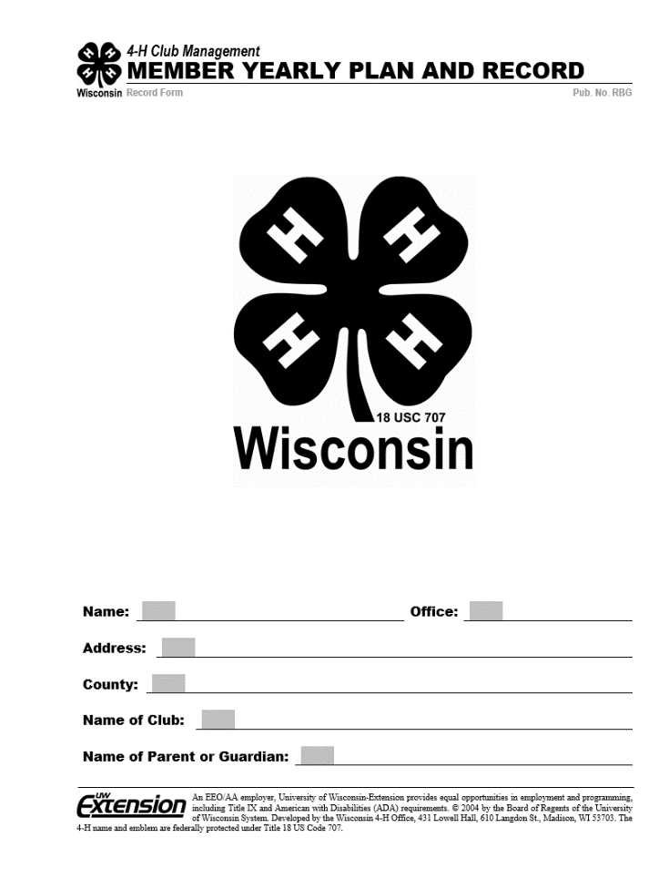

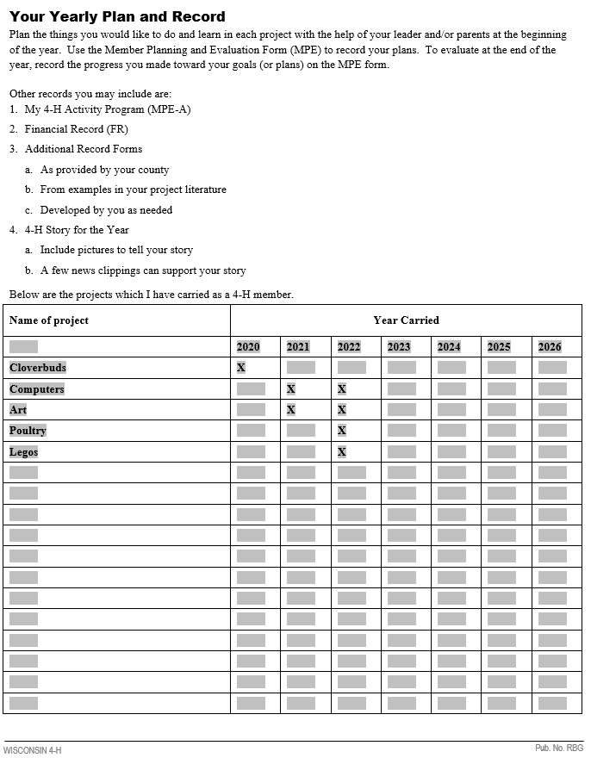

**Outside of the Front Cover**The cover should be printed on Kelly Green cardstock.  
You will need to fill out your name, the office that you held this 4-H year (if there was one), your full address (including city, state and zip), the name of your club and your parent or guardian’s name(s).

**Inside of the Front Cover**  
This is a running record of the projects that you, the member, are enrolled in each year. The easiest way to fill this out is to list each project area down the left hand side of the page (skipping the first row). Just add any new project areas below as shown here.   
For the years, fill in your year at the top of the box as shown here. Then you can place an X in each box that you were enrolled in those projects as shown.

**Member Record Page**This page should be on white paper as with the rest of the record pages unless stated.  
Here is where you record your demographic information.   
The date should be the year as of January of the current year. So for the 2024-2025 school or 4-H year, you would put ‘24. This goes for every page that has a date area in the upper right corner.  
You will then put a current picture of yourself. You could back the picture to add a splash of color to the page.  
Members, you should be sure to check the box at the bottom to state that this is representative of your true and own work, and then sign the page. 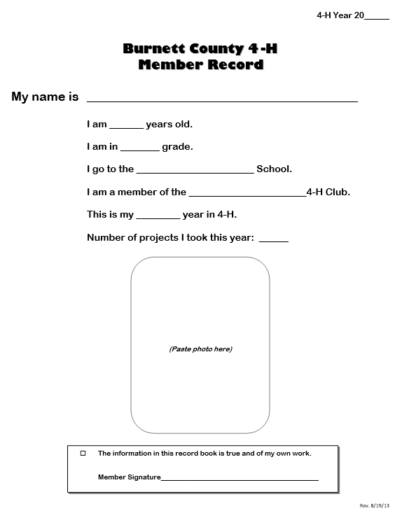

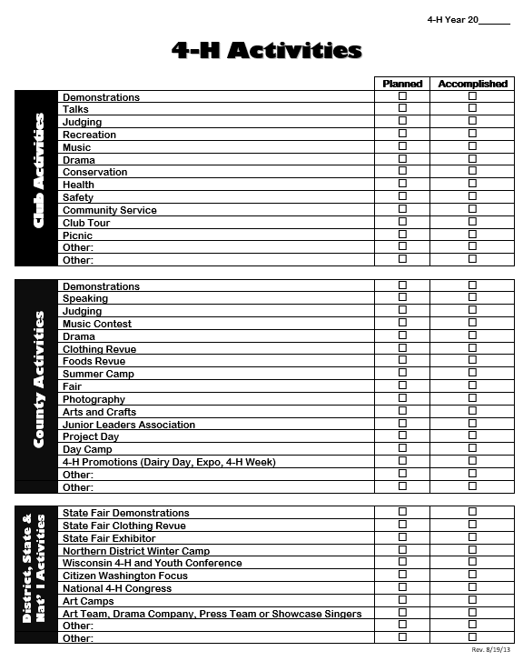

**4-H Activities Page**This page is a place to check or X the boxes for the Planned and Accomplished columns. Start this page at the beginning of the year with marking what you plan to do. At the end of the year (after the fair, before the record books are due, or as you complete those activities) mark the accomplished column. Feel free to write in on the line behind the title what you did, i.e. Music Contest: Piano Solo – Ode to Joy.

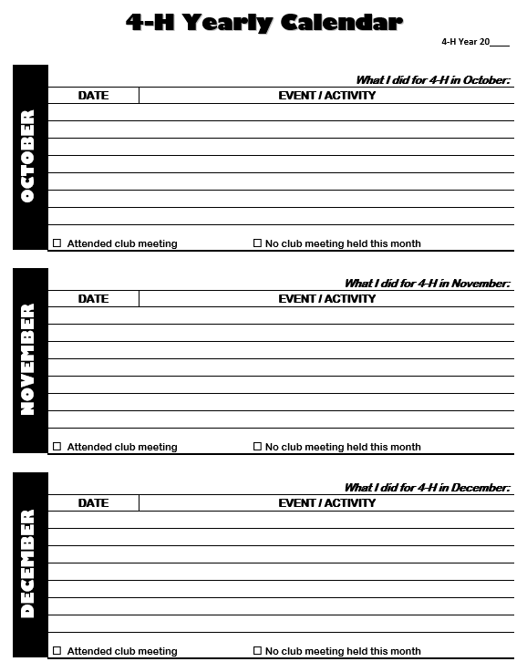

**4-H Yearly Calendar Pages (4)**These document pages are the member’s places to record monthly events. (HINT: something should be documented in each month, even if it says “I was unable to attend the meeting this month.”  
Please be sure to include the date of each activity, then list out those activities. These can be Club meetings, project meetings, tours, bell ringing, sledding, etc. Also check if the member attended the meeting box or if the meeting was not held. Be sure that the member fills out all 4 pages (usually printed back to back) so the entire year is covered.

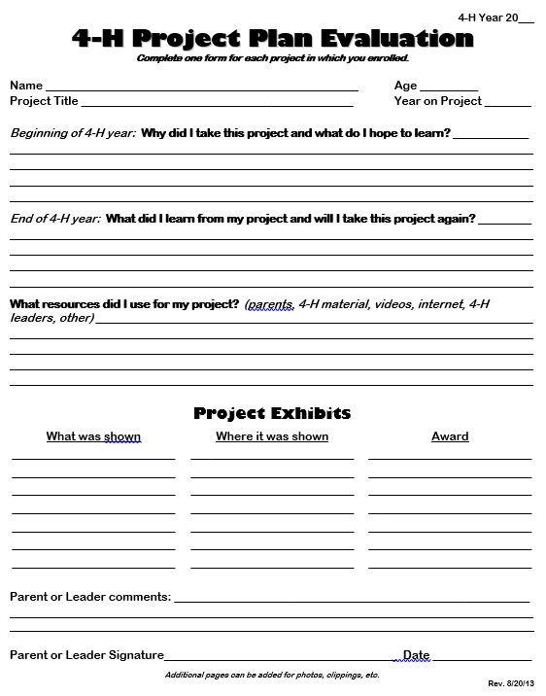

**4-H Project Plan Evaluation Pages**  
You should have one of these pages for each project area that you are enrolled in. So one page for each X in the inside of your front cover for the current year. Start these pages early in the year and answer the question: Why did I take this project and what do I hope to learn? Then at the end of the year you answer the rest of the questions of what you did learn and will you take the project again? And what resources did you use? Record the exhibits that you enter in the Fair or Cultural Arts for the project area, where you exhibited and what you received on it. Be sure to have your parent/guardian or leader add comments and signature to the bottom of the page.

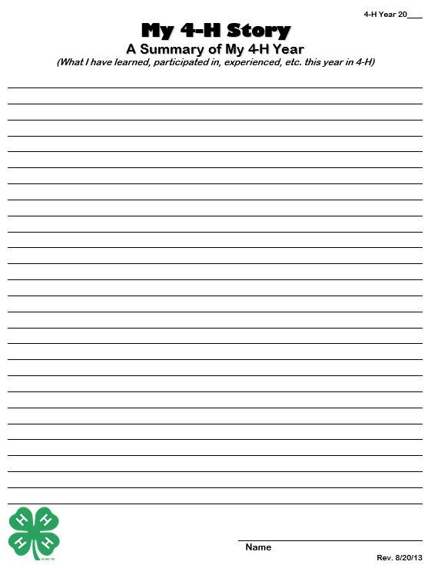

**4-H Youth Leadership Plan (2)**  
These pages should be completed by anyone enrolled in Youth Leadership as a project, anyone who has a leadership role such as an officer and/or part of the Jr. Leaders Group for the county. This is a confusing form so please ask a leader with experience to walk you through it if you get stuck.  
For each of the 5 sections there is space to document leadership opportunities throughout the year. Each of those areas you will write your plan (name of activity or job, what members will learn, who will help you, when it will take place) and your results. You don’t have to have something in all 5 areas, just be sure to document what you did (being an officer, helping fundraise, service learning, leading a project or demonstration, leading at project day, etc.). The opportunities are endless.  
  
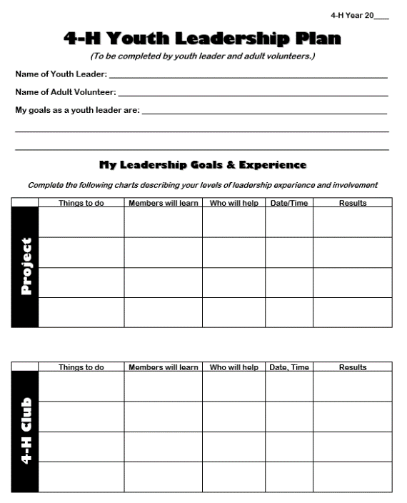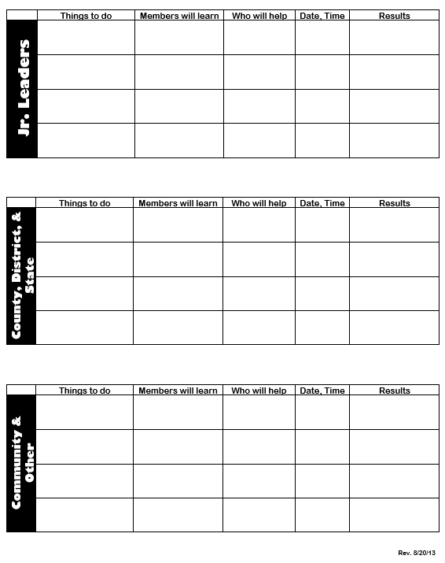

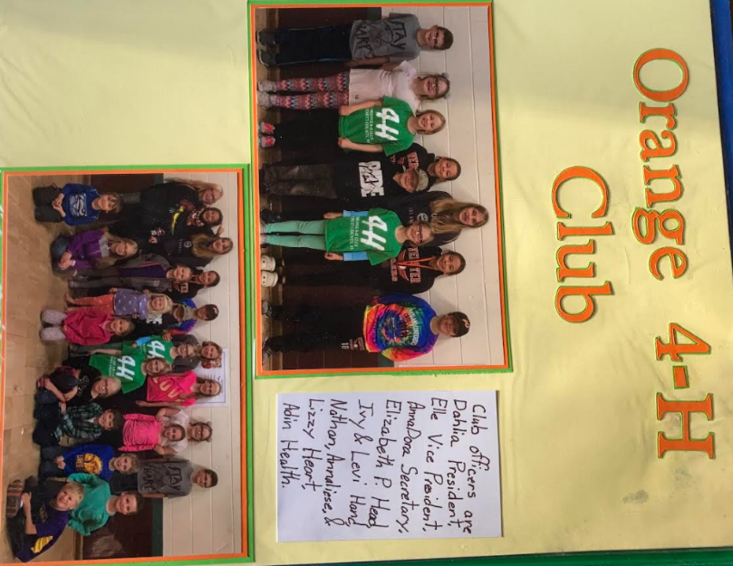

**My 4-H Story Page**  
Use this page to share your 4-H story. You do not have to write a book, but you should share what you did that you enjoyed the most, learned, why you joined 4-H and what do you look forward to next year. The leaders look for quality and not quantity. Be sure to check for spelling, grammar, sentence structure and punctuation.

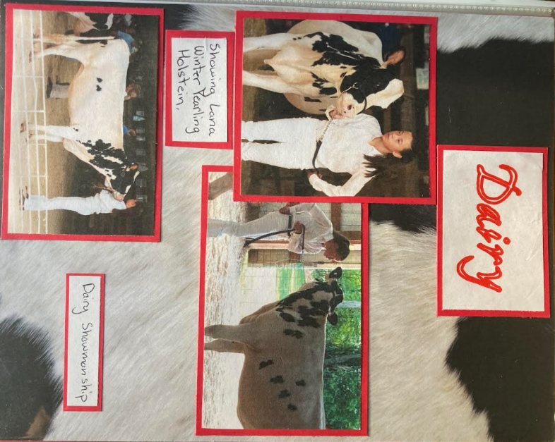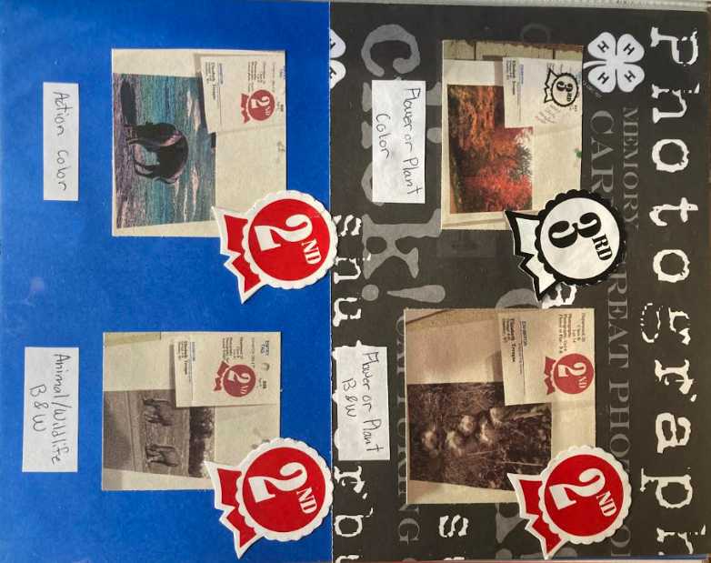

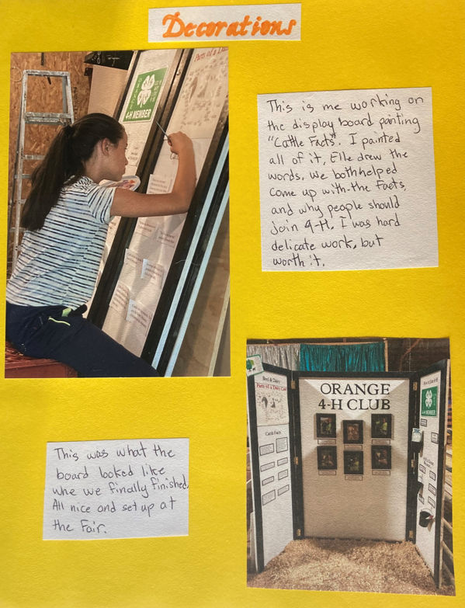

**Extra Pages You Should Consider Including**  
It goes above and beyond to have extra pages that have pictures, judging sheets, newspaper clippings, etc. that show activities that you have participated in throughout the current year, projects taken to the Fair or other shows. Please don’t put in ribbons or the white fair entry tags (you can cut out the stickers that you get at the fair that are usually stuck to the fair entry tags and put the cut out stickers in your book instead), full programs from events or full newsletters. You can dress up these pages as much as you would like if you are into scrapbooking and such or you can just be neat and tidy with descriptions under pictures and other things you have included. If your name is listed, it is always nice to highlight your name in the article or clipping.   
(**HINT:** make sure these extra pages are 8 ½ X 11 and fit correctly in your Record Book. Please do not make them scrapbook sized at 8 X 8 or 12 X 12.)

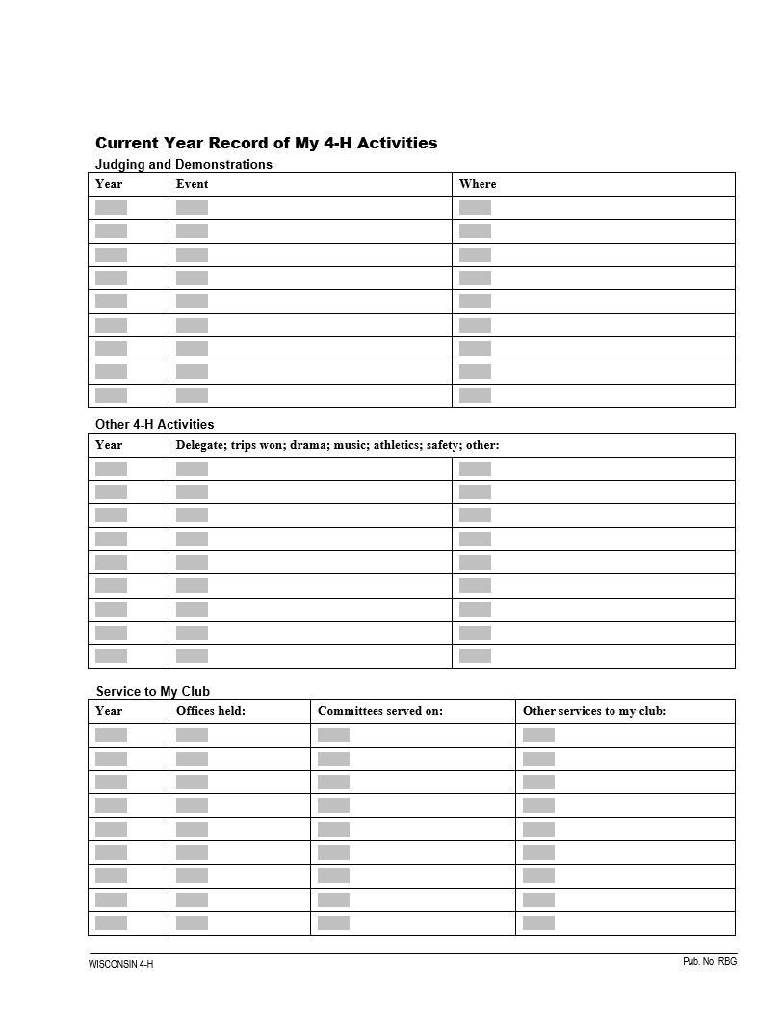

**Inside of the Back Cover**  
The first section is a place to list if and where you have done any demonstrations or judging events such as Dairy Judging or Meat Judging.  
The middle section is a place to record other 4-H activities that you have been a part of. Try and put those activities from each year on the same line (otherwise you will fill them up very quickly). These things can be participation in drama or music at the club/county/state level, delegate to any 4-H conferences, award trips, etc.  
The last section is the space to record offices held (if any), committees served (if any), other services to the club (such as working in the food stand, road clean-up, bell ringing, any community service activities.

**Outside of the Back Cover**You are done and do not need to do anything with this page.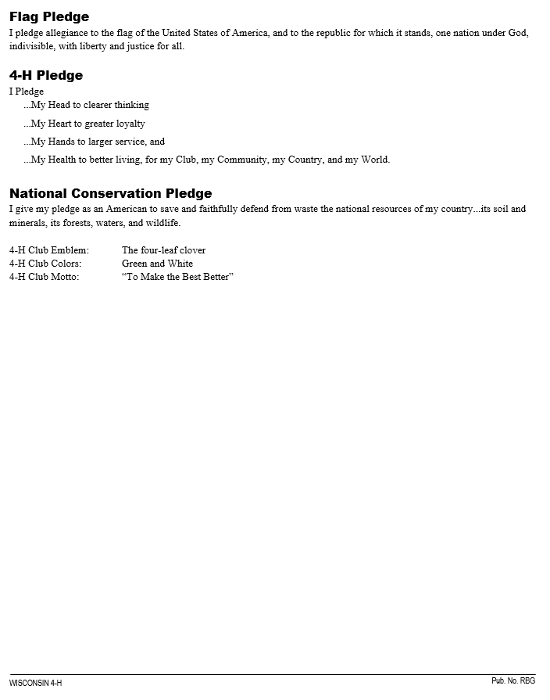

Congratulations, you’re all done with your Record Book!!

# **Appendix B – Grant Application**

This application for project funding can be downloaded at http://burnett.uwex.edu/4-h-youth-development. See pages 13-14 of this guide for more information. Grant application forms are submitted with your Record Book for the upcoming year’s project. 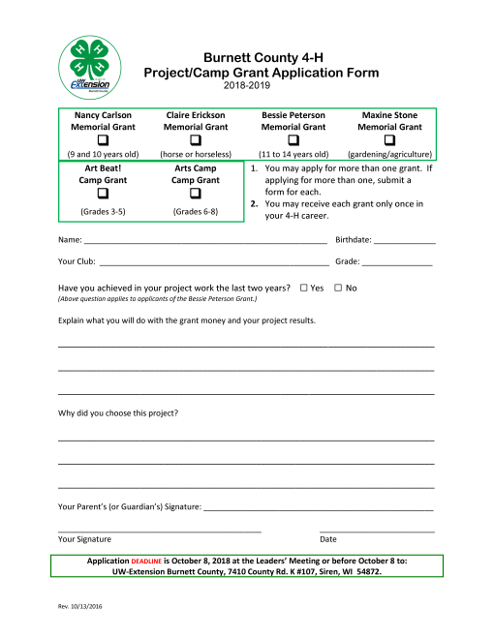

**Appendix C – Scholarship Application**

This application for a post-secondary scholarship can be downloaded at http://burnett.uwex.edu/4-h-youth-development. See page 14 of this guide for more information. 